# Introduction:

## Benefits of Migrating to Cloud

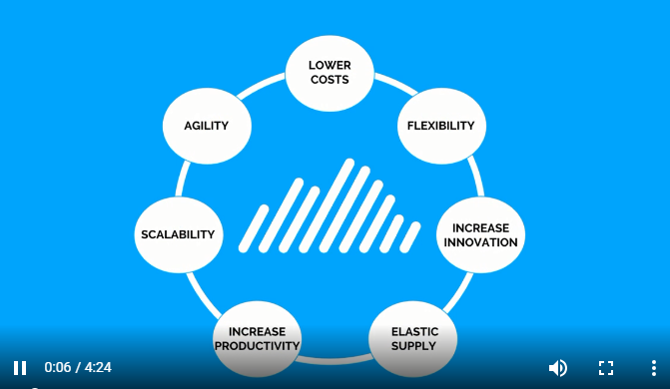

## How Cloudamize works

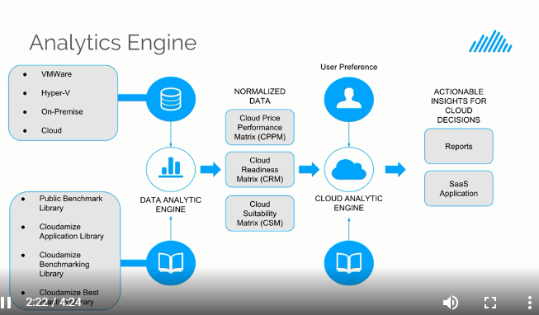

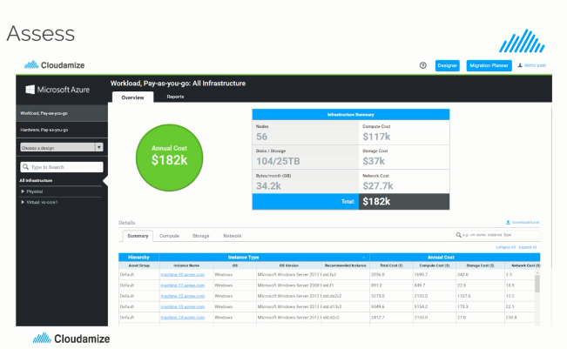

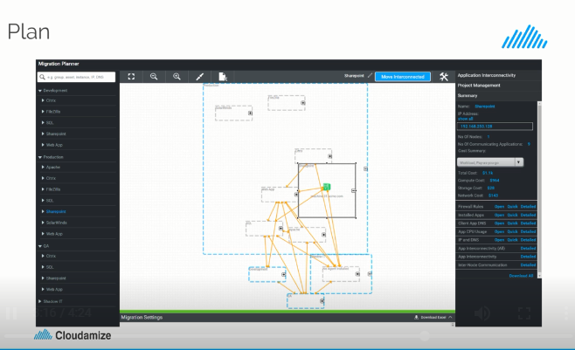

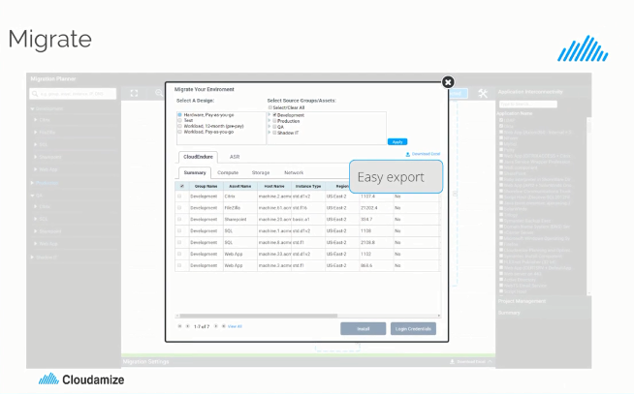

## Cloudamize Dashboard

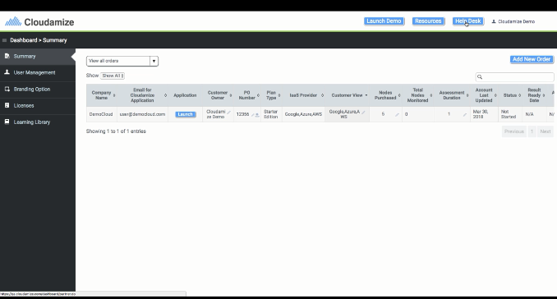

### Create an Assessment

* Create an assessment by clicking ***Add New Order***
* Fill Details
* Click submit and return to the dashboard

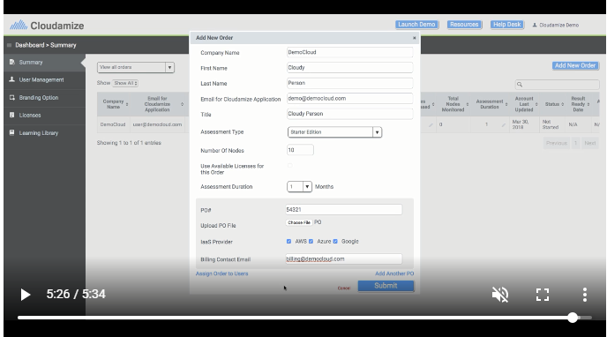

### Cloudamize Demo

Click on View Details in below snap.

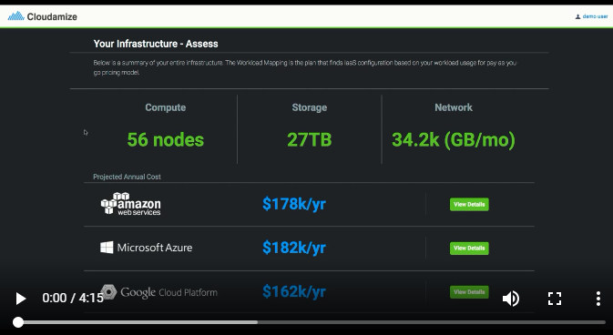

Contains four sections:

* Summary
* Compute
* Storage
* Network

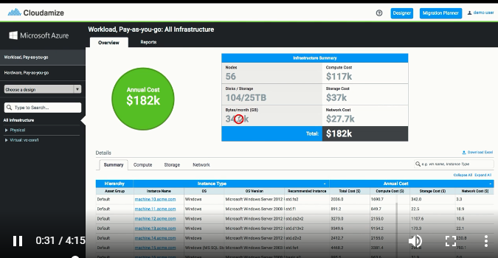

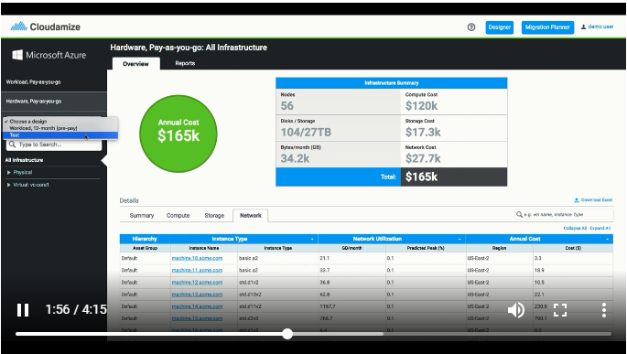

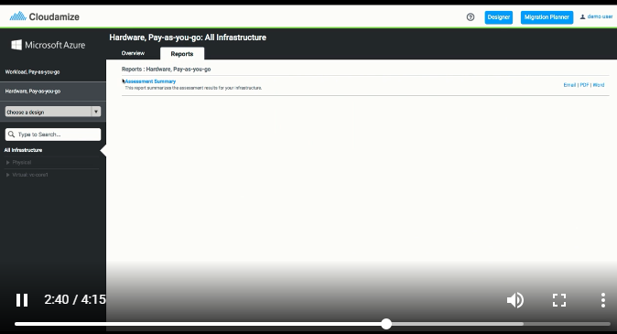

Click on Wizard

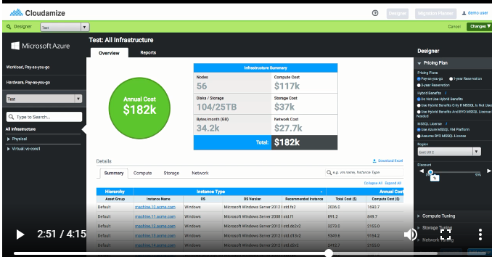

### Migration Planner

You can design your own migration planner without modifying the existingone.

Development -> Assets -> Machines

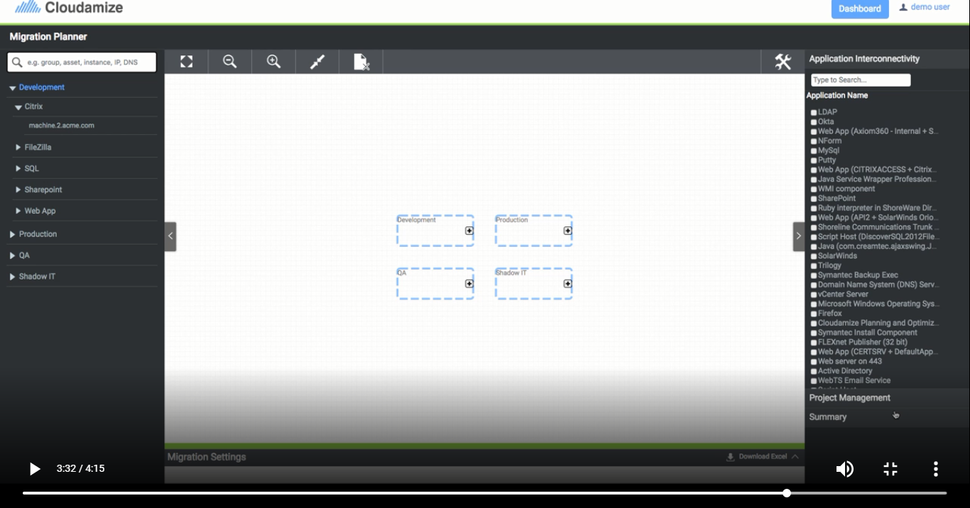

## Agent Vs Agentless

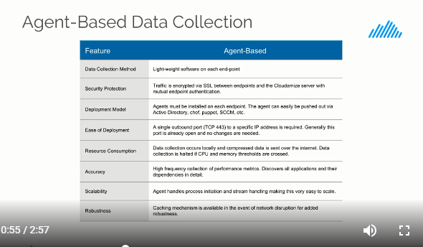

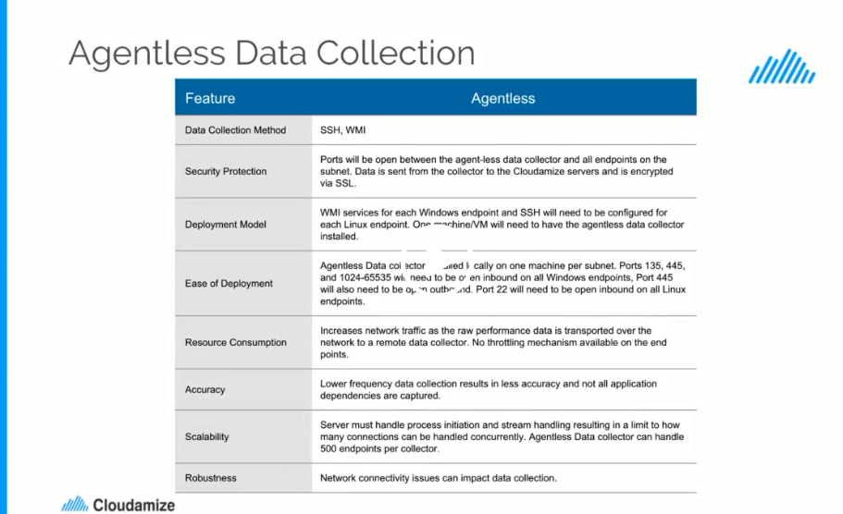

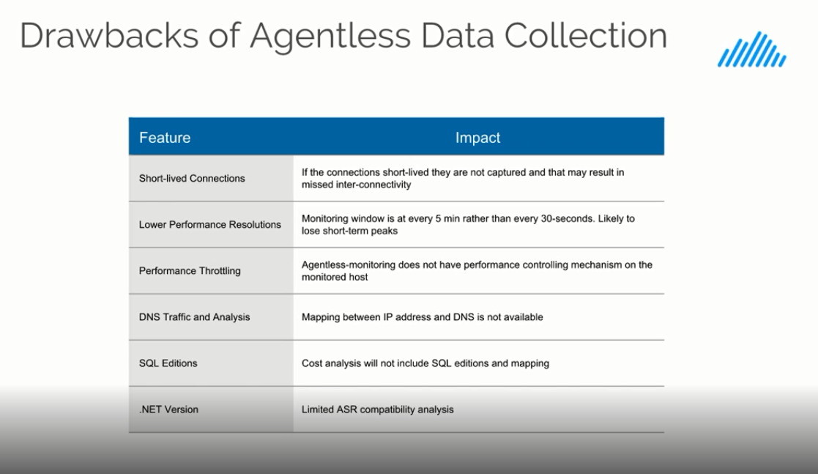

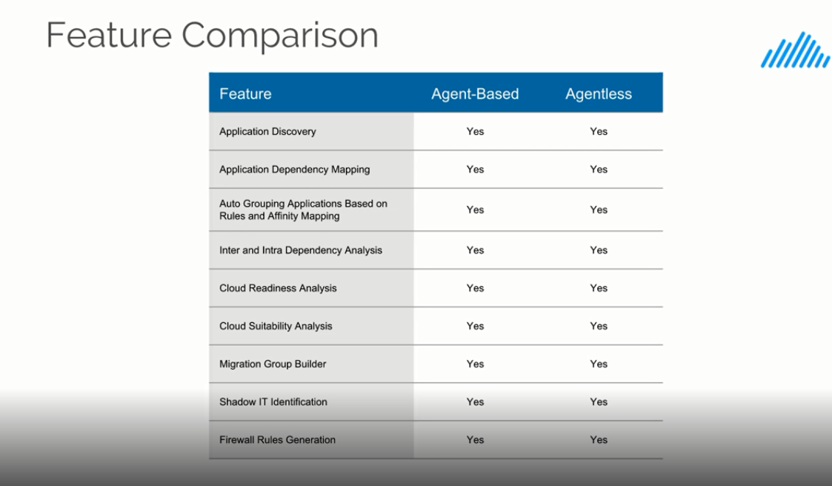

## Understanding the Results

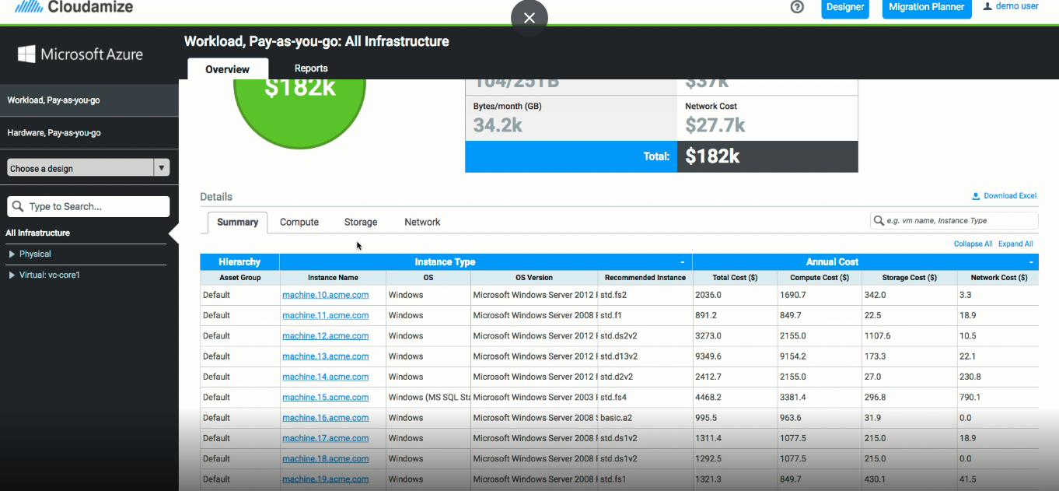

# Contents

* **WELCOME TO CLOUDAMIZE**
* [**Welcome to Cloudamize**](https://cloudamize.talentlms.com/unit/view/id:2918)
* [**Partner Dashboard Overview**](https://cloudamize.talentlms.com/unit/view/id:2919)
* **AGENT V. AGENTLESS**
* [**Agent v. Agentless**](https://cloudamize.talentlms.com/unit/view/id:2920)
* **AGENTLESS INSTALLATION**
* [**Agentless Data Collector Installation Overview**](https://cloudamize.talentlms.com/unit/view/id:2921)
* [**Add and Configure Hosts**](https://cloudamize.talentlms.com/unit/view/id:2922)
* **VCENTER INSTALLATION**
* [**vCenter Installation Instructions - Proxy Setup**](https://cloudamize.talentlms.com/unit/view/id:2923)
* [**vCenter Installation Instructions - Read Only Credentials**](https://cloudamize.talentlms.com/unit/view/id:2924)
* [**vCenter Troubleshooting - Restarting the VMware Management Agent**](https://cloudamize.talentlms.com/unit/view/id:2925)
* [**vCenter Troubleshooting - Proxy to vCenter Accessibility**](https://cloudamize.talentlms.com/unit/view/id:2926)
* [**vCenter Troubleshooting - Network and Firewall Access Tests**](https://cloudamize.talentlms.com/unit/view/id:2927)
* [**vCenter Troubleshooting - Invalid Login Information**](https://cloudamize.talentlms.com/unit/view/id:2928)
* **WINDOWS/HYPER-V INSTALLATION**
* [**Windows Installation Instructions**](https://cloudamize.talentlms.com/unit/view/id:2929)
* [**Hyper-V Installation Instructions**](https://cloudamize.talentlms.com/unit/view/id:2930)
* [**Agent Deployment with GPO and Active Directory**](https://cloudamize.talentlms.com/unit/view/id:2931)
* [**Uninstall Cloudamize Windows Agent**](https://cloudamize.talentlms.com/unit/view/id:2932)
* **LINUX INSTALLATION**
* [**Linux Installation Instructions**](https://cloudamize.talentlms.com/unit/view/id:2933)
* [**Uninstall Cloudamize Linux Agent**](https://cloudamize.talentlms.com/unit/view/id:2934)
* **ASSESSMENT SETTINGS OVERVIEW**
* [**Inventory Settings - Physical Infrastructure**](https://cloudamize.talentlms.com/unit/view/id:2935)
* [**Inventory Settings - Virtual Infrastructure**](https://cloudamize.talentlms.com/unit/view/id:2936)
* [**Inventory Settings - Physical and Virtualized Infrastructure**](https://cloudamize.talentlms.com/unit/view/id:2937)
* [**Inventory Settings - Assessment Status**](https://cloudamize.talentlms.com/unit/view/id:2938)
* [**Inventory Settings - User Management**](https://cloudamize.talentlms.com/unit/view/id:2939)
* [**Inventory Settings - User Profile**](https://cloudamize.talentlms.com/unit/view/id:2940)
* [**Inventory Settings - Start an Assessment**](https://cloudamize.talentlms.com/unit/view/id:2941)
* **UNDERSTANDING AZURE ASSESSMENT RESULTS**
* [**Azure - Assess Dashboard Overview**](https://cloudamize.talentlms.com/unit/view/id:2942)
* [**Azure - How to Interpret your Summary Results**](https://cloudamize.talentlms.com/unit/view/id:2943)
* [**Azure - How to Interpret your Compute Utilization Results**](https://cloudamize.talentlms.com/unit/view/id:2944)
* [**Azure - How to Interpret your Storage Utilization Results**](https://cloudamize.talentlms.com/unit/view/id:2945)
* [**Azure - How to Interpret your Network Utilization Results**](https://cloudamize.talentlms.com/unit/view/id:2946)
* [**Azure - How to Interpret your Machine Utilization Results**](https://cloudamize.talentlms.com/unit/view/id:2947)
* **AZURE DESIGNER OVERVIEW**
* [**Azure - Getting Started with the Designer**](https://cloudamize.talentlms.com/unit/view/id:2948)
* [**Azure - Customizing Pricing Plan Options**](https://cloudamize.talentlms.com/unit/view/id:2949)
* [**Azure - Customizing Compute Options**](https://cloudamize.talentlms.com/unit/view/id:2950)
* [**Azure - Customizing Storage Plan Options**](https://cloudamize.talentlms.com/unit/view/id:2951)
* [**Azure - Customizing Network Load Options**](https://cloudamize.talentlms.com/unit/view/id:2952)
* **MIGRATION PLANNER OVERVIEW**
* [**Getting Started with the Migration Planner**](https://cloudamize.talentlms.com/unit/view/id:2953)
* [**How to Use the Application Inventory Settings**](https://cloudamize.talentlms.com/unit/view/id:2954)
* [**Build Machine-Based Move Groups**](https://cloudamize.talentlms.com/unit/view/id:2955)
* [**Build Application-Based Move Groups**](https://cloudamize.talentlms.com/unit/view/id:2956)
* **How to Use Advanced Filtering**
* **Create CSV-based Move Groups**
* **Create Custom CSV Output**
* **Undo Changes in the Migration Planner**
* **Shadow IT**

# Demo Videos:

# Welcome to Cloudamize

## [Partner Dashboard Overview](https://cloudamize.talentlms.com/unit/view/id:2919)

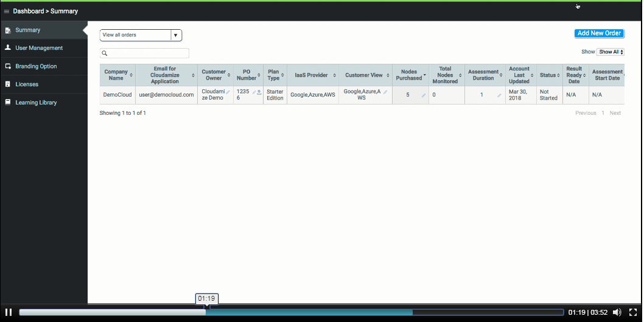

Admin users can only be created by Super Admin

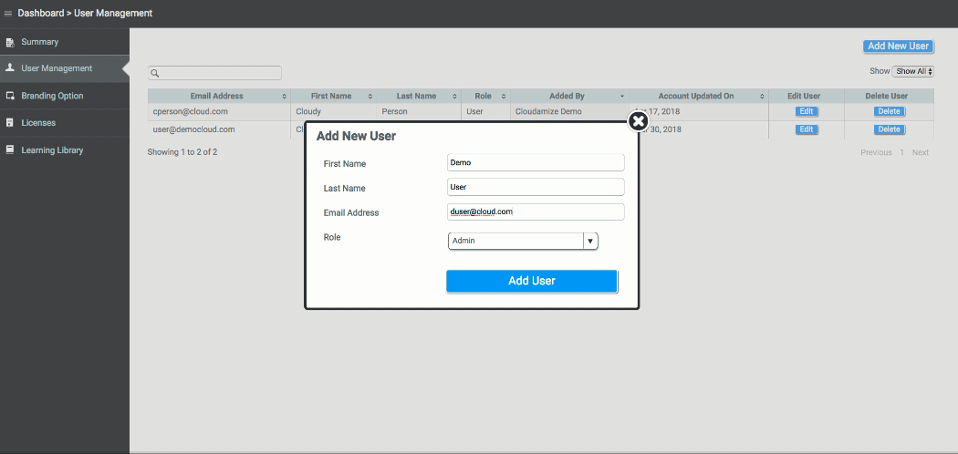

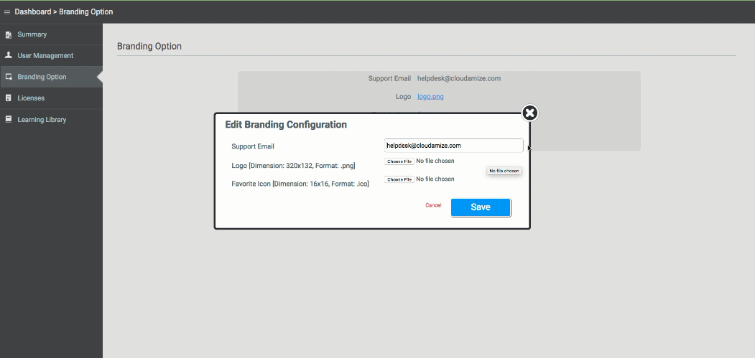

Consumed and available Licenses will be displayed

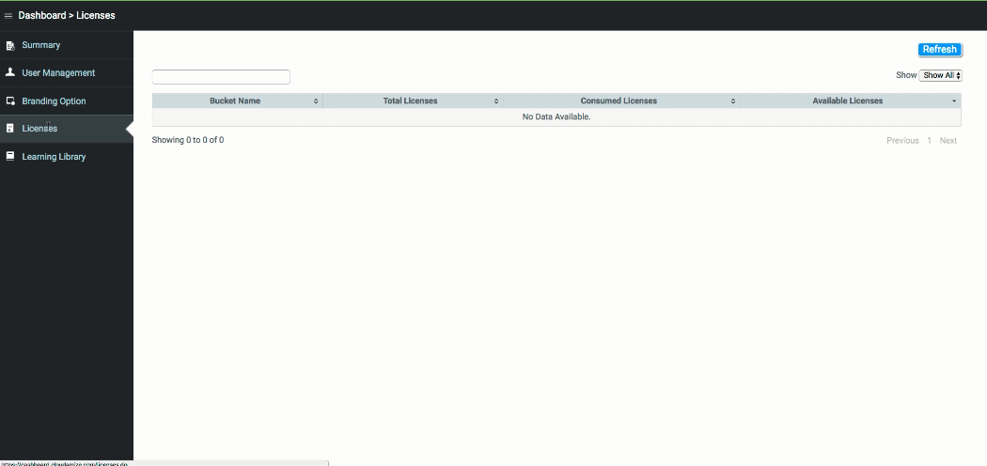

Review & Refresh the knowledge by videos

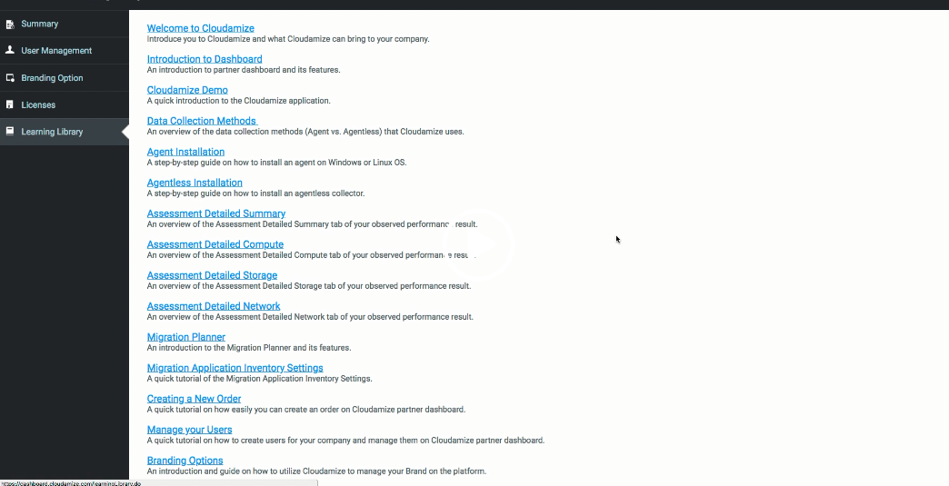

# Agent v. Agentless









# Agentless Installation

## Agentless Data Collector Installation

**Introduction**:

This guide will walk you through setting up the Cloudamize Agentless Data Collector. Once the collector is set up, you will be able to discover and assess up to 500 Windows and Linux physical and virtual machines on the subnet.

Relevant Ports:

The table below lists relevant ports for machine discovery and communication to the Cloudamize servers. Please note the following rules for each class of machine:

* Machine with Cloudamize Agentless Data Collector installed:

TCP port ​445 ​open ​inbound TCP ports ​443​ and a proxy server port if a proxy server is being used open outbound

* Each Windows endpoint:

TCP ports ​135​ and range ​1025-65535​ open ​inbound TCP port ​445​ open ​outbound​ to our servers at ​104.197.11.97

* Each Linux endpoint:

TCP port 22 ​open inbound Along with these ports, ICMP inbound and outbound communications should also be allowed.

Minimum Requirements: The Cloudamize Agentless Data Collector will need to be installed on a physical or virtual Windows machine meeting the following minimum requirements (based on monitoring 500machines):

●64-bit Windows Operating System

●.NET framework version 4.0

●4 core CPU

●5 GB RAM

●2 GB persistent storage

**Setup Instructions:**

The Cloudamize Agentless Data Collector can easily be installed using a Graphical User Interface.

Upon launching the installer, you will see the following window. Click next to continue to the End User License Agreement. Review and accept the terms in the License Agreement and click Next to continue.

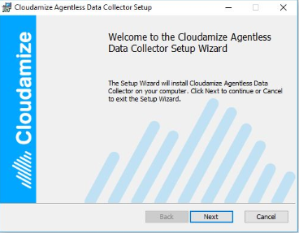

Next, you will be required to enter your customer key. If you choose to route the data through your own proxy, you can enter the address, port, username, and password on this screen. Click next once you are ready to continue.

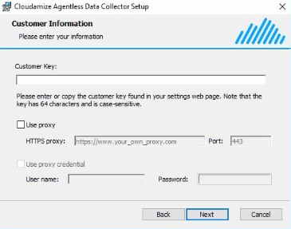

Click install to begin the Cloudamize Agentless Data Collector Installation.

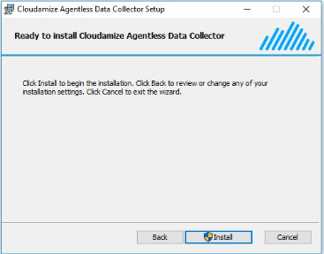

Once the installation completes, click Finish to close the installer. You are now ready to begin adding and configuring hosts for data collection. If you have any questions about the above process, please [contacthelpdesk@cloudamize.com](mailto:contacthelpdesk@cloudamize.com)

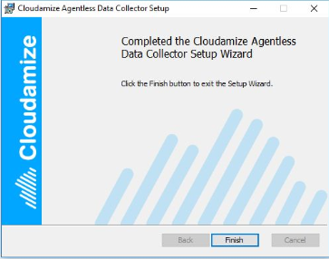

## Add and Configure Hosts

**Launching the UI**

Open the Cloudamize Agentless Data Collector. This can be done from the windows taskbar using the following instructions

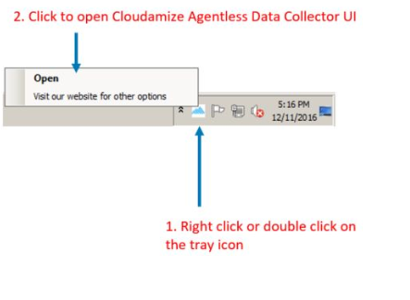

**Adding Hosts**

Hosts are added using IP addresses and can be done individually (10.1.1.2), as a range

(10.1.1.2-50), or as a subnet (10.1.4.0/24). You may use any combination of these formats

Separated by a comma. Once the IP address has been entered, click Add host(s)

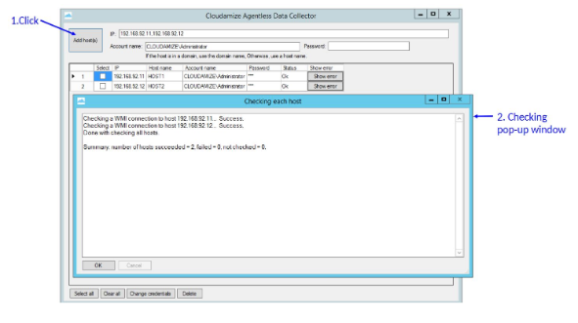

After clicking Add host(s), another window will open to check the WMI connection to each host and report success or failure. A summary will appear at the bottom of the window displaying the number of hosts which succeeded, failed, and were not checked. Hosts will not be checked if Cancel​ is clicked during the check process.

**View Error Messages**

If the WMI connection fails for any reason the Status column will display Error. You can click on the Show error button ​to the right of ​Status​ to learn more.

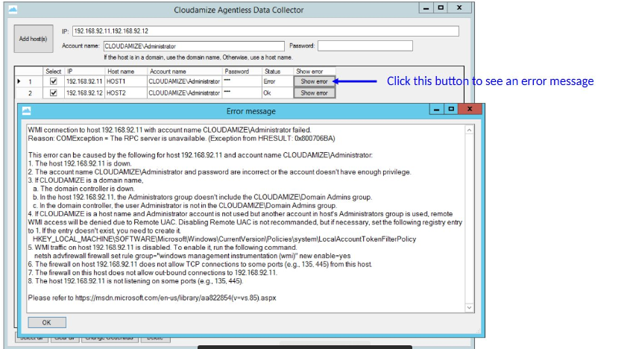

Clicking ​Show error​ will open a window with more information on the error. Please refer tothis page​ for steps to troubleshoot WMI connection issues. You can review the information inthe pop-up window and attempt to fix the error or contact ​helpdesk@cloudamize.com​ forassistance.

**Change Credentials**

You can edit the credentials of a host by clicking the checkbox​ on the left row and selecting Change credentials​ at the bottom.​​The changes made to the credentials will now be displayed in the Data Collector.

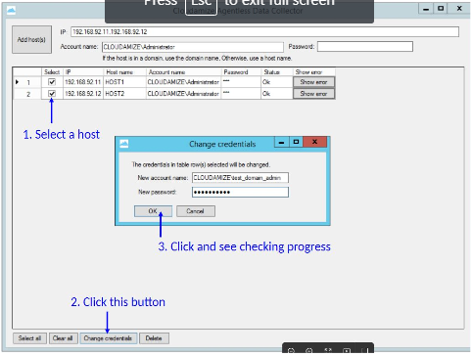

# vCenter Installation

## vCenter Installation Instructions - Setting Up the Cloudamize Proxy

**Introduction**

If your vCenter IP address is a private IP address, you will need to install a Cloudamize Proxy that will forward data to Cloudamize server.

**How Does It Work?**

The Cloudamize Proxy can be installed either directly on the vCenter machine or on a separate Windows virtual machine. The proxy is unique per vCenter and VM. For example, if you have two vCenters, you will need two unique proxies that will need to get installed on either two Windows VMs or two vCenters.

You will need to allow outbound traffic on port 443 to IP address 184.73.183.154. You will also need to allow traffic on port 443 from the VM or vCenter with the Cloudamize Proxy installed to the vCenter IP address. Alternatively, the Cloudamize vCenter Proxy supports traffic over port 22 and port 80. If you choose to use either of these ports, please be sure to check that your firewall configuration is set correctly

**Setting Up the Cloudamize Proxy**

1. A window prompting you to download the Cloudamize Proxy will appear immediately after entering your private IP address. Click Download.

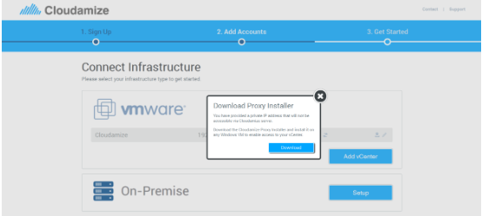

1. Once downloaded, run the installer as an administrator and click Next

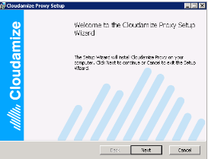

1. Read and accept the terms of the End-User Agreement and click Next.
2. Enter your vCenter IP address and port. Select the Outgoing Port to Cloudamize server. Cloudamize recommends No preferenceas this will search 443, 80, and 22 to determine the best port to use. Then click Next.

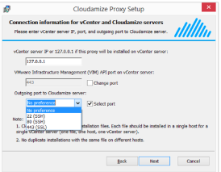

1. Click Installto begin the installation.

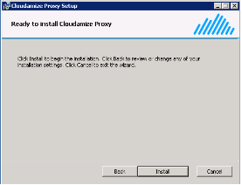

1. Following a successful installation, CONNECTEDwill appear on the following screen. Additional vCenters can be added by clicking Add vCenterand repeating the steps in this section.

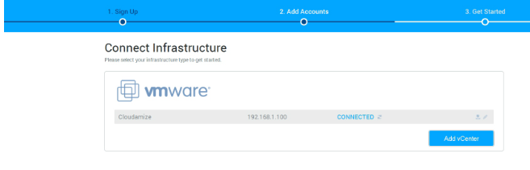

## vCenter Installation Instructions - Creating vCenter Read Only Credentials

**Introduction**

This guide will lead you through the process of allowing Cloudamize read-only access to your vCenter.

**Creating vCenter Read Only Credentials**

1. Log in to the machine which is hosting your vCenter and create a new user account.

2.Assign the new user to the Usersgroup. Click on the Member oftab and select Users.

3.Go to your vCenter management dashboard, right-click the vCenter, and select Add Permission.

4.Select Addfrom the Assign Permissions screen.

5.From the user and groupslist, select the new read-only user account and click Ok.

6.Under Assign Roleselect Read-onlyand click Ok.

7.To verify the set-up was done correctly, select the Permissionstab from your vCenter and make sure the role for the newly created account is set to read-only.

8.Enter a name for the vCenter, the IP address (public or private), and the read-only credentials just created.

9.If your vCenter has a public IP address, then you will need to make sure TCP port 443 is open outbound to our vCenter data collector at IP address 184.72.252.123. Once you have entered and saved your vCenter information, you should see the status as CONNECTED.

10.If your vCenter has only a private IP address, then you will need to make sure TCP port 443 is open outbound to our vCenter proxy at IP address 184.73.183.154. Then continue on to set up the Cloudamize proxy which establishes a connection between your vCenter and the Cloudamize vCenter data collector.

## vCenter Troubleshooting - Restarting the VMware Management Agent

**Problem**

VMware vCenter collects data from ESXi servers with an agent. When this agent crashes, no performance data is available from the host and any VM that runs on the host

**Solution**

* First, verify the existence of this problem by using the vCenter Client to observe whether performance data is available for VMs running on impacted hosts. To observe performance data, open vCenter Client and go to Home > Inventory > Hosts and Clusters and then select a host that is missing performance data. Select Performance > Advanced select a CPU performance metric and then select Past Month.
* You should see the message, "Performance data is currently not available for this entity"which confirms that the performance collection between this ESXi server and your vCenter is not working properly. Alternatively, some performance data might be available, but no recent data is available.
* If performance data is not available, usually this problem can be fixed by restarting the VMware Management Agent. The following two links will assist you in resolving this issue.

Troubleshooting gaps in performance data or missing performance data in vCenter Server (1003878)

Restarting the Management agents in ESXi (1003490)

**Note:** this link is especially relevant when you are using HA (high availability) as it gives instructions on how to restart the data collection agent without the HA taking any action. Specifically, see the instructions after, "Caution: Ensure Automatic Startup/Shutdown of virtual machines is disabled before running this command or you risk rebooting the virtual machines."

**vCenter TroubleshootingProxy to vCenter Accessibility**

**Introduction**

This guide will assist you in diagnosing accessibility issues between your vCenter and Cloudamize servers.

**Problem**

After the installation of the Cloudamize Proxy, the status of the connection to your vCenter is DISCONNECTED with a message such as:

***Connection Refused:*** *We notice that you installed the Cloudamize Proxy correctly but we are unable to reach your vCenter. Please make sure that you entered the correct information (eg. IP and Port) of your private vCenter."*

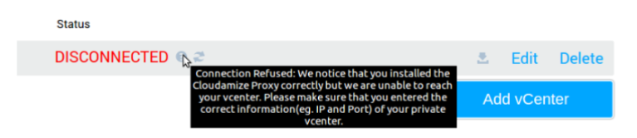

**Solution:**

This particular error occurs when the Cloudamize Proxy is accessible from our servers, but the Proxy is not able to connect to your vCenter.

Please check the accessibility of your vCenter from the machine where the Cloudamize Proxy is installed.

* Open a browser and go to https://<vcenter-ip-address-provided-during-installation>
* You should see the following welcome screen in your browser:

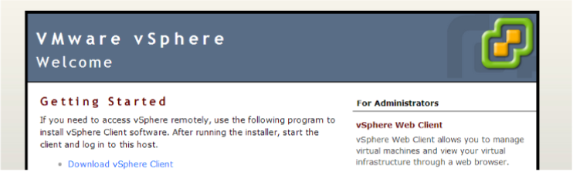

If you are not able to see a similar vCenter welcome page, then please check that your machine has access to the vCenter machine on port 443.

**Check using Curl:** curl.exe <vcenter_ip_address>:443

**Note:** Curl is not installed by default on some Windows versions. Please follow these steps to install Curl on your machine: <http://curl.haxx.se/download.html>

Check using Telnet: telnet <vcenter_ip_address> 443

**Note:** Telnet is not installed by default on some Windows versions. Please follow these steps to install Telnet on your machine: <http://technet.microsoft.com/en-us/library/cc771275(v=ws.10).aspx>

If you notice that you entered an incorrect IP, please remove the Cloudamize Proxy that you installed by double-clicking on the installer that you downloaded from Cloudamize. Then reinstall the Proxy with the correct IP address for your vCenter

Press refreshon the Cloudamize setup page and check the error message.

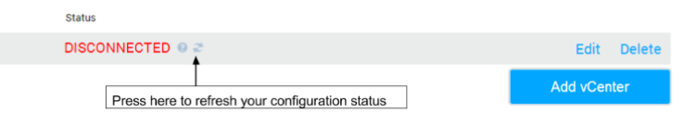

If the error message on the Cloudamize connection status page has changed to CONNECTED then the installation was successful.

If you notice that you are receiving a different error such as, "Invalid Login: The credentials provided were not accepted by your vCenter endpoint. Please check that the read-only account credentials provided to Cloudamize match your local setup.", Please refer to Post-Installation Invalid Login Informationfor directions on how to troubleshoot the problem.

If the error message continues to read,"Connection Refused: We notice that you installed the Cloudamize Proxy correctly but we are unable to reach your vCenter."after going through these steps, please contact helpdesk@cloudamize.comfor further assistance.

**Problem**:

No Web service is running

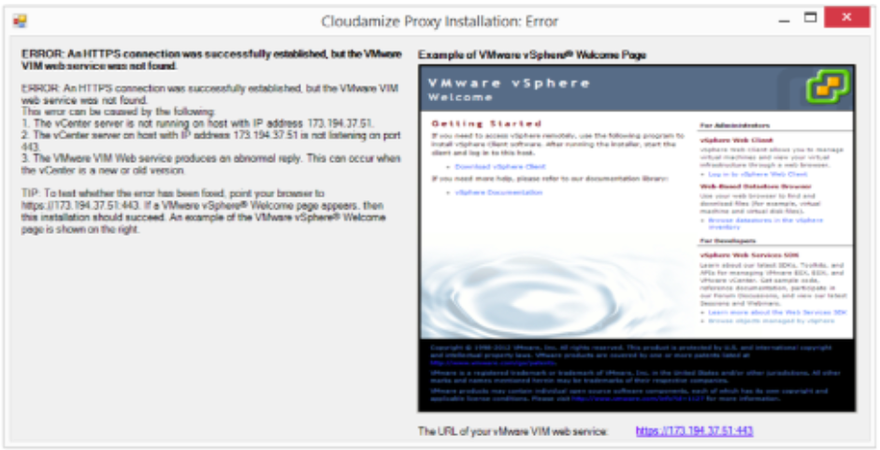

**Solution:**

If Applicable, Please ignore this error

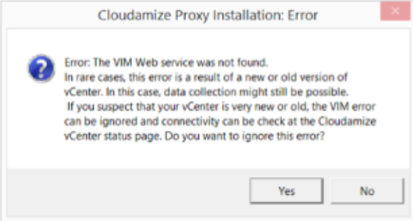

## vCenter Troubleshooting - Network and Firewall Access Tests

**Introduction**

This guide will assist you in diagnosing network and firewall related connection issues between your vCenter and Cloudamize servers

**Problem:**

After the installation of the Cloudamize Proxy, the status of the connection to your vCenter is DISCONNECTED and has a message such as:

"Connection Refused: Please make sure that you installed the Cloudamize Proxy correctly. The Proxy should be installed on a machine that has access to the Vcenter as well as to the internet."

"UnknownException: An unknown error was encountered using the information entered. Please check the information that you provided and contact helpdesk@cloudamize.com for further assistance."

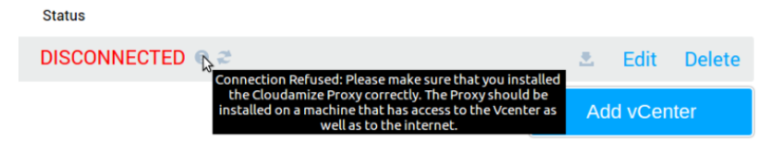

**Solution:**

The machine where the Cloudamize Proxy is installed needs to have access to the internet and to your vCenter machine.

Check that your machine is permitted to send outbound traffic to Cloudamize servers on port 443.

■Using Curlcommand: curl.exe 184.73.183.154:443output:SSH-2.0-OpenSSH

■Note: Curl is not installed by default in some Windows versions. Please follow these steps to install Curl on your machine: <http://curl.haxx.se/download.html>

Using Telnet - telnet 184.73.183.154 443

■Note: Telnet is not installed by default in some Windows versions. Please follow these steps to install Telnet on your machine: <http://technet.microsoft.com/en-us/library/cc771275(v=ws.10).aspx>

If unable to connect, please check that your machine is permitted to send outbound traffic to google.com on port 443

.■Using Curlcommand: curl.exe google.com:443output:<HTML><HEAD><meta http-equiv="content-type" content="text/html;charset=utf-8">

....

■Note: Curl is not installed by default in some Windows versions.

Please follow these steps to install Curl on your machine: <http://curl.haxx.se/download.html>

■Using Telnettelnet google.com 443

■Note: Telnet is not installed by default in some Windows versions. Please follow these steps to install Telnet on your machine: <http://technet.microsoft.com/en-us/library/cc771275(v=ws.10).aspx>

If unable to connect, please check that your firewall allows outbound traffic on port 445 to IP 184.73.183.154.

Please wait two minutes and refresh your configuration on the Cloudamize Setuppage.

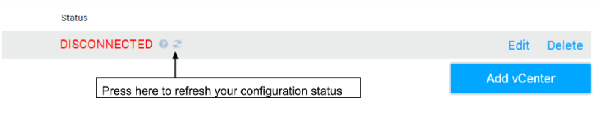

If the Curl connection to 184.73.183.154 succeeds and you are still getting the same error message, please check that the Cloudamize Proxy is installed and working properly.

■Check that the Cloudamize Proxy is runningCommand:tasklist /svcoutput:Cloudamize-Connector.exe <pid> Cloudamize-Connector

■If you do not see the Proxy installed, then reinstall the previously downloaded Proxy.

■Check that the connection is established with the Cloudamize serversCommand:netstat -anotoutput:TCP <localip>:<localport> 184.73.183.154:443 ESTABLISHED

●If the connection is established, please wait two minutesand refresh your configuration on the Cloudamize Setuppage.

* If the error message on the Cloudamize connection status page haschanged to CONNECTEDthen the installation was successful.
* If you notice that you are getting a different error, such as: "Connection Refused: We notice that you installed the Cloudamize Proxy correctly but we are unable to reach your vCenter", please refer to Post-Installation Proxy to vCenter Accessibilityfor directions on how to troubleshoot this problem.
* If the error message remains the same, "Connection Refused: Please make sure that you installed the Cloudamize Proxy correctly."
* After going through these steps, please contact helpdesk@cloudamize.comwith the results of the above tests and the log.txtfile located in either C:\Program Files (x86)\CloudamizeProxyor C:\Program Files\CloudamizeProxy.

## vCenter Troubleshooting - Invalid Login Information

**Problem**

●After the installation of the Cloudamize Proxy, the status of the connection to your vCenter is DISCONNECTED with a message such as:

"Invalid Login: The credentials provided were not accepted by your vCenter endpoint. Please check that the read-only account credentials provided to Cloudamize match your local setup."

**Solution**

●This error occurs when the username and password provided during the registration is not accepted by the vCenter authentication mechanism

●Please open a browser and go to https://<vcenter_ip_provided_during installation>

●Under the For Administratorsheading, click on Browse datastores in the vSphere inventory.

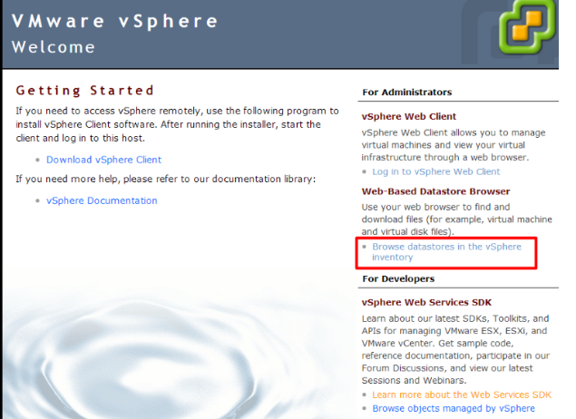

* A window will open asking you to enter your vCenter username and password. Enter the same credentials you used on the Cloudamize Web registration form

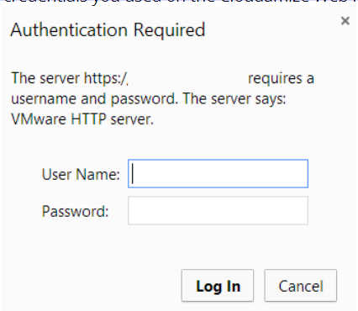

If you are unable to login to the vCenter Datastore using these credentials:

* Check that you have the correct username and password provided by Cloudamize.
* Update your vCenter information on the Cloudamize website.

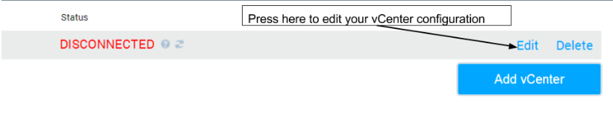

* If you are using an active directory domain accountto access your vCenter, please enter your username in the following format:

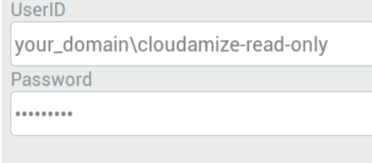

* If you are using a local accountto access your vCenter please enter your username in the following format:

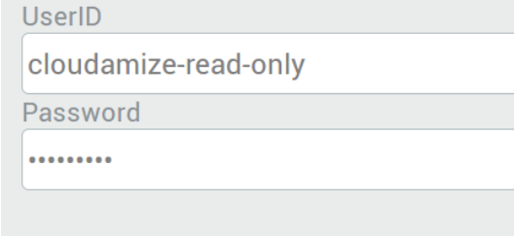

* If you are still not able to connect after following this guide, please contact helpdesk@cloudamize.comfor further assistance.

# WINDOWS/HYPER-V INSTALLATION

## Windows Installation Instructions

**Introduction**

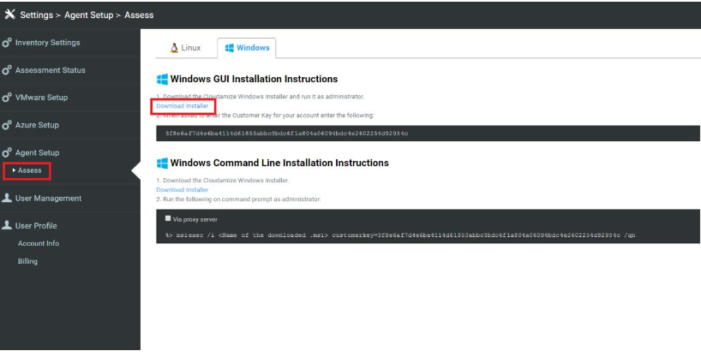

**Download the Cloudamize Windows Agent**

1.Launch the Cloudamize agent and click Settingsunder your user account.

2.Click on the Windowstab in the Agent Installation.

3.Choose GUI or command line installation and click Download Installerto begin downloading an MSI file.

4.Before running the MSI, please make sure that you have opened outbound port 443.This is necessary to complete a direct connection with the Cloudamize server. You can also specify your own proxy server during installationwhich will then route agent communication to the Cloudamize server.

**GUI (Graphical User Interface) Installation**

1. Upon launching the installer, you will see the following window.

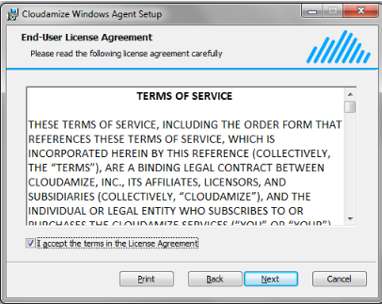

1. Accept the End-User License Agreement and click **Next**. Enter the customer key that was generated for you and is available on the **Cloudamize Agent Installationwebpage**. To use your proxy server, enable Use proxyand type in the **HTTPS proxy** and **Port**. If your proxy server needs user credentials, enable Use **proxy credential** and enter the **User** **name** and **Password**. Click **Next**.

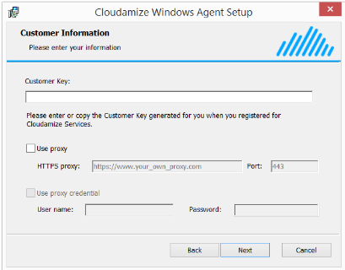

1. Click "Install" and give permission to Windows if requested.

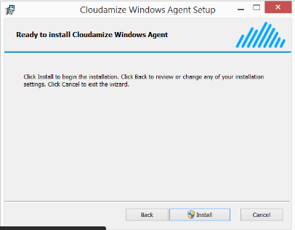

1. Installation status and details information will be shown. In order to ensure successful deployment of the agent, connectivity to Cloudamize servers, OS corruption, and several other error scenarios are tested. For this reason, this step can take several minutes. In the event that a problem is detected, instructions are given to help resolve the problem. If needed, please contact Cloudamize for assistance at [helpdesk@cloudamize.com](mailto:helpdesk@cloudamize.com).

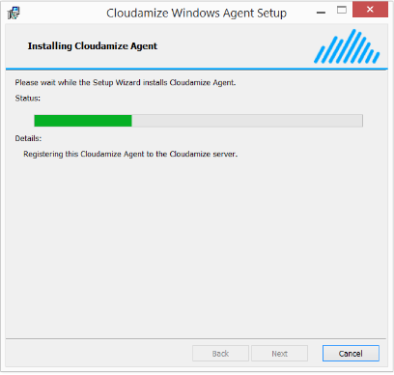

1. Click Finish.

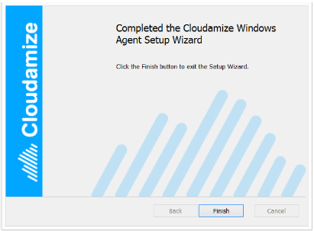

**Command Line Installation with GUI**

This method is suitable for stand-alone servers (that is, Windows machines without a GUI). In this case, the same pop-up dialog boxes will appear as in the GUI-based installation.

Please select one of the following commands and run it as administrator(i.e., run Command Prompt as administrator and type in one of the commands).

* When a proxy server is not used:

msiexec /i <downloaded MSI file> CUSTOMERKEY="your key"

* When a proxy server is used but proxy credentials are not used:

msiexec /i <downloaded MSI file> CUSTOMERKEY="your key"USE_PROXY=1 HTTPS_PROXY="https://www.your_own_proxy.com" PROXY_PORT="your_proxy_server_port"

* When a proxy server is used and proxy credentials are used:

msiexec /i <downloaded MSI file> CUSTOMERKEY="your key"USE_PROXY=1 HTTPS_PROXY="https://www.your_own_proxy.com” PROXY_PORT="your_proxy_server_port" USE_PROXY_CREDENTIAL=1 PROXY_USER_NAME="user_name" PROXY_PASSWORD="password"

* When a connection problem occurs, the installer will try to connect to the Cloudamize server for 24 hours. To limit the installation maximum duration due to a connection problem:

msiexec /i <downloaded MSI file> CUSTOMERKEY="your key" INSTALL_MAX_DURATION_IN_MIN=60

**Note**: Unit of INSTALL_MAX_DURATION_IN_MIN is minuteand 60 minutes are set in this example.

**Additional Options:**

* IS_PROXY_CERTIFICATE_SIGNED_BY_CA

■0: Skip the proxy certificate verification with proxy server option. This is the default value.

■1: Verify the proxy certificate.

* IS_SERVER_CERTIFICATE_SIGNED_BY_CA

■0: Skip the server certificate verification.

■1: Verify the server certificate. This is the default value.

**Command Line Installation with Silent Mode and without GUI**

**Note**: We recommend first attempting the installation with the GUI. Once installation is successful on a handful of machines, the command-line method can be used.

Please select one of the following commands and run it as **administrator**.

When a proxy server is not used:

msiexec /i <downloaded MSI file> CUSTOMERKEY="your key" /qn

●When a proxy server is used but proxy credentials are not used:

msiexec /i <downloaded MSI file> CUSTOMERKEY="your key" USE_PROXY=1 HTTPS_PROXY="https://www.your_own_proxy.com" PROXY_PORT="your_proxy_server_port" /qn

●When a proxy server is usedand proxy credentials are used:○msiexec /i <downloaded MSI file> CUSTOMERKEY="your key"USE_PROXY=1 HTTPS_PROXY="https://www.your_own_proxy.com” PROXY_PORT="your_proxy_server_port" USE_PROXY_CREDENTIAL=1 PROXY_USER_NAME="user_name" PROXY_PASSWORD="password" /qn

●When a connection problem occurs, the installer will try to connect to the Cloudamize server for 24 hours. To limit the installation maximum duration due to a connection problem:○msiexec /i <downloaded MSI file> CUSTOMERKEY="your key" INSTALL_MAX_DURATION_IN_MIN=60 /qn

■Note: Unit of INSTALL_MAX_DURATION_IN_MIN is minute and 60 minutes are set in this example.

●Additional Options:○IS_PROXY_CERTIFICATE_SIGNED_BY_CA

■0: Skip the proxy certificate verification with proxy server option. This is the defaultvalue

■1: Verify the proxy certificate.○IS_SERVER_CERTIFICATE_SIGNED_BY_CA

■0: Skip the server certificate verification.

■1: Verify the server certificate. This is the default value.

**Note that in many cases, the installation command will return immediately and does not provide any indication of success or failure.**

In some cases, the msiexec command fails, for example, when the MSI file is not accessible or missing. If the command returns without an error, then the installation will progress and could take some time to complete. In this case, the success or failure can be determined with the Windows EventViewer as follows.

1.Execute the EventViewer.

2.Click Windows Logs →Application.

3.Filter Current Log and set Event Source to **MsiInstaller**. One of three outcomes is possible:

1. An event is found with a message indicating successful installation of the agent, for example, the message text includes Product:

Cloudamize Windows Agent --Installation completed successfully.

1. An event is found with a message indicating failure, for example, the message text includes **Product: Cloudamize Windows Agent --Installation failed.**
2. In this case, detailed error messages can be found in the Event Log by searching for Windows Logs →Application, setting Event Source to **Cloudamize Windows Installation**.
3. If any event is found, please follow the instructions shown in the event details. If needed, please contact Cloudamize for assistance at [support@cloudamize.com](mailto:support@cloudamize.com) or via phone at 215-557-3735.
4. Neither of the above events is found, in which case the installation is still underway.
5. In order to ensure a successful installation, problems with connectivity are resolved by re-attempting connections. These re-attempts will continue for up to 24 hours, allowing installation to withstand significant network outages. For this reason, it is possible that neither of the above events will appear for 24 hours.
6. If problems are encountered, Warning messages are sent to the EventViewer (with source Cloudamize Windows Installation). The event message provides information about the problem encountered
7. Generally, some message regarding success, failure, or a problem will appear in the Event Log within 10 minutes after the msiexec command is executed.
8. One problem that can arise is when a proxy is used and the username or password are set incorrectly, In this case, connectivity through the proxy is reattempted for 24 hours. In this case, a warning message can be observed with the EventViewer. To fix the problem reattempt installation after failure message appears in the Event Log. Alternatively, installation can be manually terminated. However, when manually terminating installation, it is criticalthat all msiexec processes are terminated and the processes are terminated in the correct order

## Hyper-V Installation Instructions

**Introduction:**

For configuration of Hyper-V hosts, click on the Windows tab for GUI installation instructions or the command line instructions. You will be installing the Windows agent on your Hyper-V host machine. For command line installation instructions, please download the installer first then execute the command as an administrator on your Hyper-V host.

For GUI-based installation instructions, please download the installer first and run the installer as an administrator. During the installer setup, you will be prompted for a Customer Key. Enter the customer key that is given on the screen.

To have instructions sent to you via email, simply click on the “Email Instructions” link

**Setting Up Hyper-V Host**

1. Open outbound port 443to IP address 104.197.11.97or the FQDN agentmanager1.cloudamize.com.
2. Once the installer is downloaded, open and click Next.

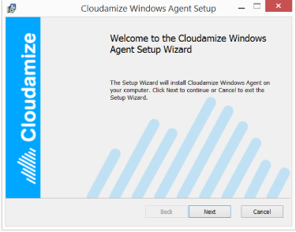

1. Accept the End-User License Agreement and click Next

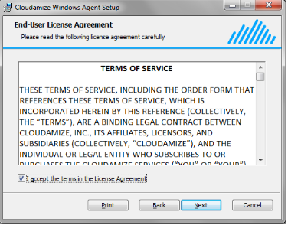

1. Enter the 64-digit customer key previously generated for you.

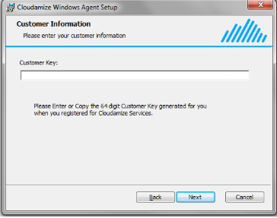

1. Click Installto begin the installation

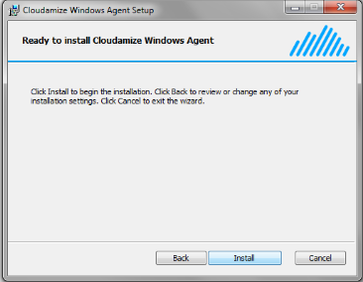

1. A status update screen will show you the progress of the installation.

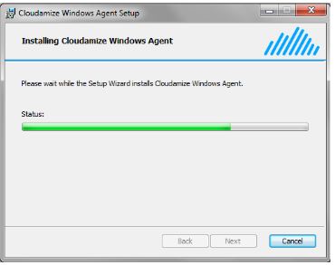

1. Once the installation is complete, click Finish

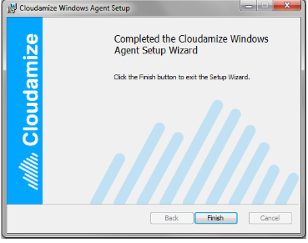

## Agent Deployment with Group Policy Object and Active Directory

**Introduction**

Network administrators can deploy and install the Cloudamize Windows Agent using a small batch file that is pushed using a Group Policy Object (GPO) and Active Directory (AD).

There are three distinct procedures that you must follow to complete the GPO deployment:

* Create and provision a network share from which to deploy the Agent installer.
* Create a GPO to identify targets for the deployment.
* Create a Windows scheduled task to deploy and install the Windows agent.

**Create a Network Share and Provision a Batch File**

To deploy the Windows Agent using GPO and AD, you must first create a network share. You will provision the share with two items:

* A batch (.bat) file that will be used to deploy the Windows Agent Installer (.msi) to network computers.
* The Windows Agent Installer (.msi) file that runs the Agent Installation on network computers.

Note: For more information about file and storage services available on Windows Server, see File and Storage Services Overview (<https://docs.microsoft.com/en-us/previous-versions/windows/it-pro/windows-server-2012-R2-and-2012/hh831487(v=ws.11)> )on Microsoft TechNet.

1. Log on to Windows Server as an **administrator**.
2. Open the Server Manager console by selecting it from the Administrative Tools menu. For more information about using the Server Manager, see Server Manageron Microsoft TechNet
3. From the Server Manager Dashboard, select File and Storage Services

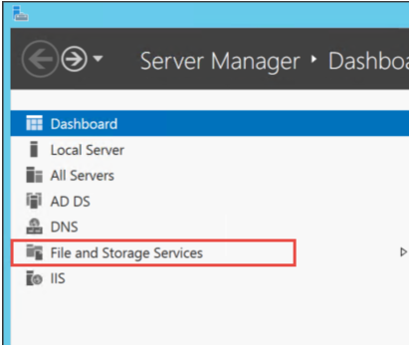

1. Select Shares, then click TASKS, then New Share...

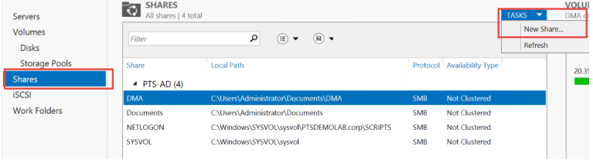

1. This will open the **New Share** Wizard. In the **wizard**, click on **Select Profile**, and select the option **SMB Share** -Quick, then click **Next**.

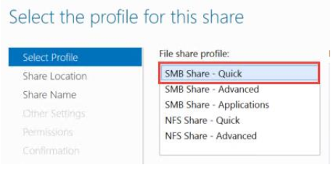

1. On the Shared **Locationtab**, enter the file path to the shared folder that you created for deploying the agent installer, then click **Next**.
2. On the **ShareName** tab, enter a name for your share. Optionally, enter a share description. Note that the wizard automatically creates the local and remote file paths to the share. Click **Next**.

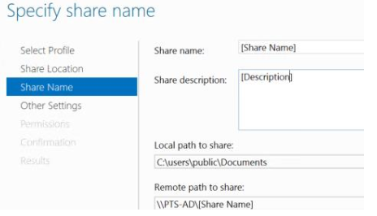

1. On the **Configure share settings** wizard page, accept the default for Other Settings: **Allow caching of share**. Click **Next**.

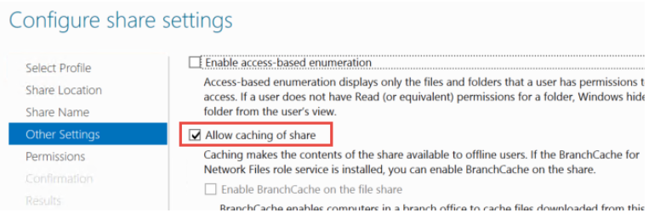

1. On the Specify permission to control access page, accept the default and click Next.
2. On the Confirm selectionspage, review your selections, then click Create
3. Your new public share is now visible in the Sharespane.
4. public share created, right-click on it and select Open Share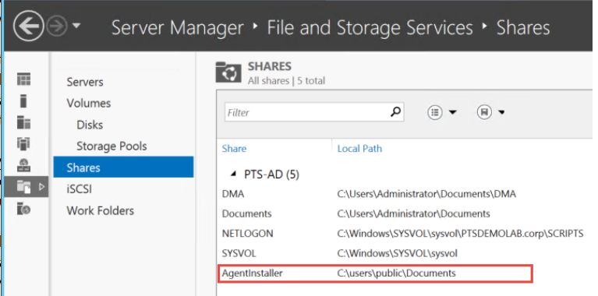
5. Place both the agent installer (.msi) file and the batch (.bat) file in the share.
6. Note: Be sure to capture and store the full network file path (not the localpath), because you will need it in a later step.

**Create a Group Policy Object (GPO) to Execute a Scheduled Task**

The next phase of the project involves creating a GPO that a scheduled task will use when it deploys and installs the DMA on network computers.

The next phase involves creating a scheduled task that will automatically deploy the Windows Agent to all of the network computers that are in the scope of the GPO you created and beginning installation.

1. Open the **Group Policy Management Editor** by right-clicking on the new GPO and select **Edit**.
2. In the editor navigation tree, under **Computer Configuration, click Preferences > Control Panel** **Settings**, and then right-click **Scheduled** **Tasks**. Click **New** and then select **Immediate Task (At least Windows 7)**

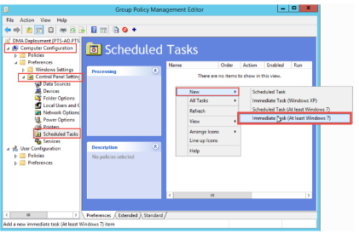

1. This presents the New Task dialog box. Enter a name and, optionally, a description.

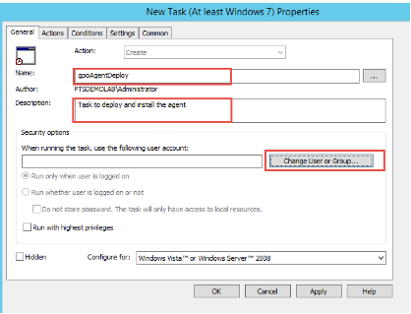

1. Under Security options, click the button **Change User or Group**... In the resulting **Select User or Group** dialog box, enter **System** in the text box, then click **Check Names**

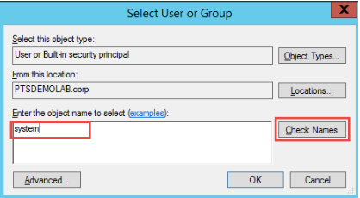

Confirm that you have the correct value and click **OK**.

1. Make sure that the system object resolves to the value **NT Authority/System** as shown in the Security options group.

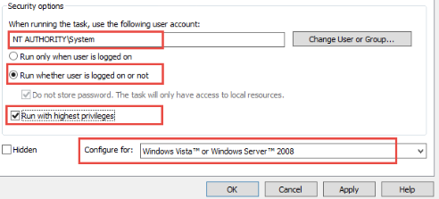

1. Be sure to check the following:
2. Ensure that Run whether user is logged on or notis selected.
3. Ensure that Run with highest privileges is selected.
4. Ensure that Configure for: is set to Windows Vista or Windows Server 2008.
5. Click on the **Actions** tab and then click **New**...
6. In the **New** **Action** dialog box, set the **Action** drop-down to **Start** **a** **program**. In the **Program**/**script** text box, enter the network file path to the shared folder that we created earlier. Finally, click **OK.**

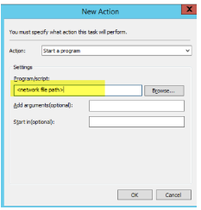

1. In the **New** **Task Properties** dialog box, select the **Conditions** tab, then select the checkbox for **Start only if the following network connection is available**, then select **Any connection**. Then click **OK**.

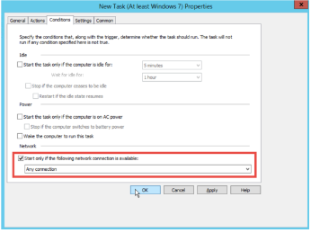

1. Close the Group Policy Management Editor, then close the Group Policy Management window

The Cloudamize Windows Agent Installer will execute on all of the selected computers at the next policy group refresh. This typically occurs every 90 minutes, but with random offsets of zero to thirty minutes.

## Uninstall Cloudamize Windows Agent

**Introduction**

This guide will walk you through the process of uninstalling the Cloudamize Agent from a

Windows machine.

**GUI Installations**

* Go to the **Control** **Panel**, select **Programs** and **Features** or **Add**/**Remove** **Programs**, and **uninstall** the **Cloudamize** **Windows** **Agent program**

**Command Line Installations:**

* The following command will uninstall the Cloudamize Windows Agent quietly. Run the command as an **administrator.**

**msiexec /x path\to\msi_file /qn**

* The following command will uninstall the Cloudamize Windows Agent via

**WMI.○wmic product where name="Cloudamize Windows Agent" call uninstall**

# LINUX INSTALLATION

## Linux Installation Instructions

**Introduction**

This guide will train you in the installation of the Cloudamize Data Collector on a Linux-based machine.

**Setting up On-Premise Linux Machines**

1. Launch the Cloudamize agent and click ​**Settings**​ under your user account.
2. Click on the ​**Linux**​ tab in the Agent Installation
3. Become root user either through ​**sudo -s ​**or **​su​.**
4. Export your customer key:
5. export CLOUDAMIZE_CUSTOMER_KEY=<YOUR CUSTOMER KEY>
6. Execute the following command to install the agent:
7. sh <(curl -shttps://agentmanager1.cloudamize.com/cxf/downloadFile/installCloudamizeAgentV2.sh)
8. If FQDN resolution is not permitted use the following command:

sh <(curl -s -khttps://104.197.11.97/cxf/downloadFile/installCloudamizeAgentV2.sh)

1. If you want to route the data through your own proxy server, click the ​via proxy servercheckbox as shown in the image below and use the following command:
2. sh <(curl --proxy https://www.yourproxy.com:proxy_port -shttps://agentmanager1.cloudamize.com/cxf/downloadFile/installCloudamizeAgentV2.sh) <https://www.your_own_proxy.com> <proxy_port>

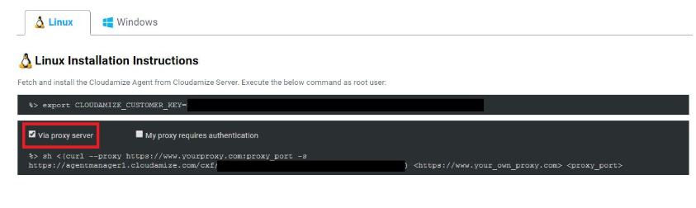

1. If you want to use your own proxy server and the server requires authentication, clickboth the ​**Via proxy server**​ and the ​**My proxy requires authentication**​ checkbox anduse the following command:
2. sh <(curl --proxy https://www.yourproxy.com:proxy_port --proxy-userusername:password -shttps://agentmanager1.cloudamize.com/cxf/downloadFile/installCloudamizeAgentV2.sh) <https://www.your_own_proxy.com> <proxy_port> <user_name><password>

## Uninstall Cloudamize Linux Agent

**Introduction**

This guide will walk you through the process of uninstalling the Cloudamize Agent from a Linuxmachine.

**Linux**

1. Go to /usr/local/cloudamize/bin
2. Run the following command:a../uninstall_cmizeagent.sh

​

​

​